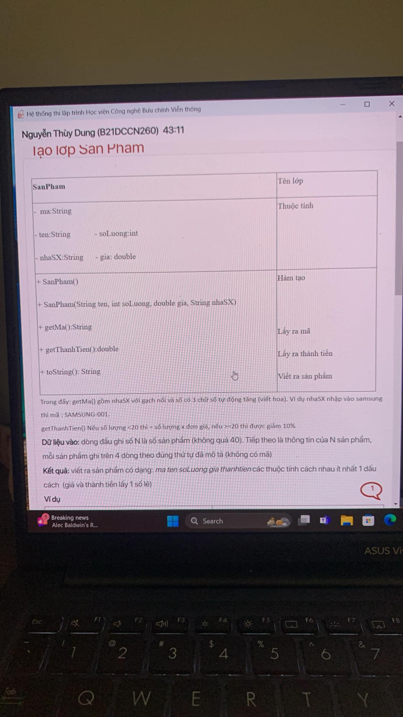

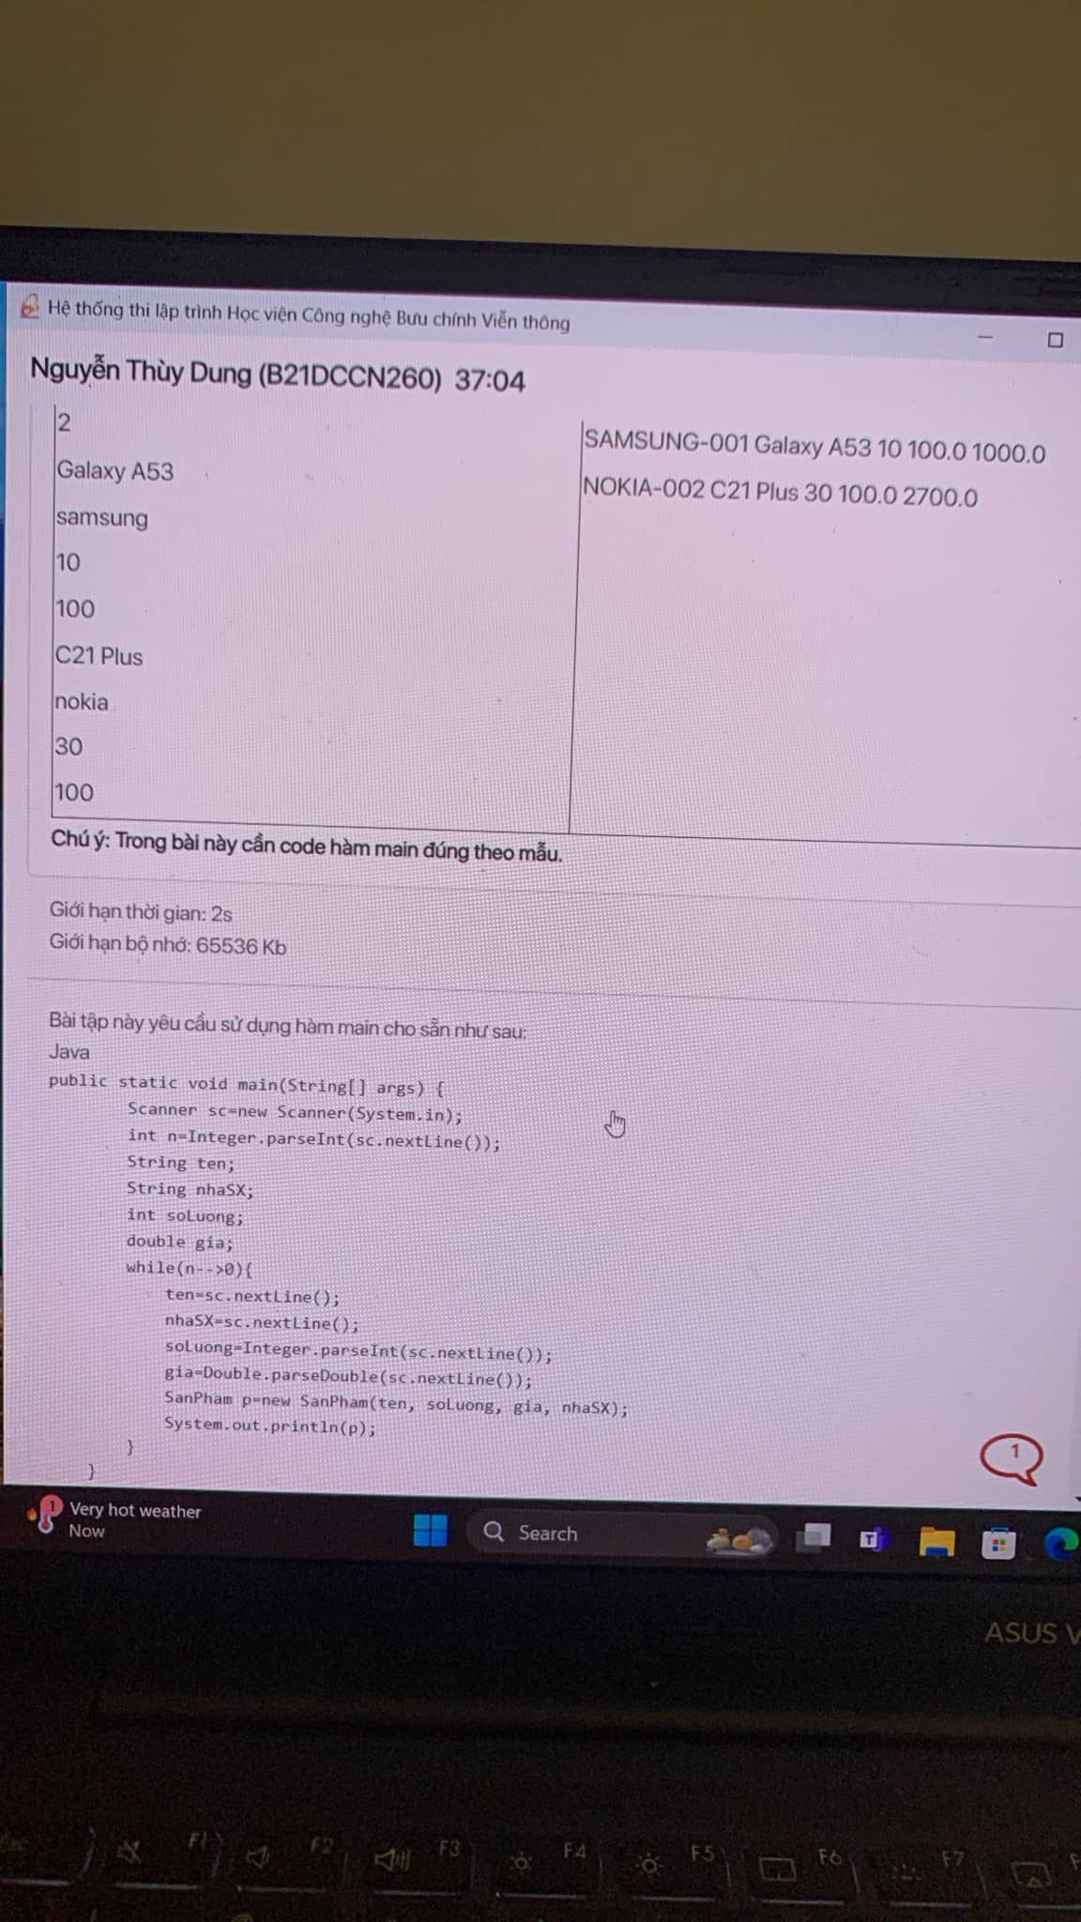

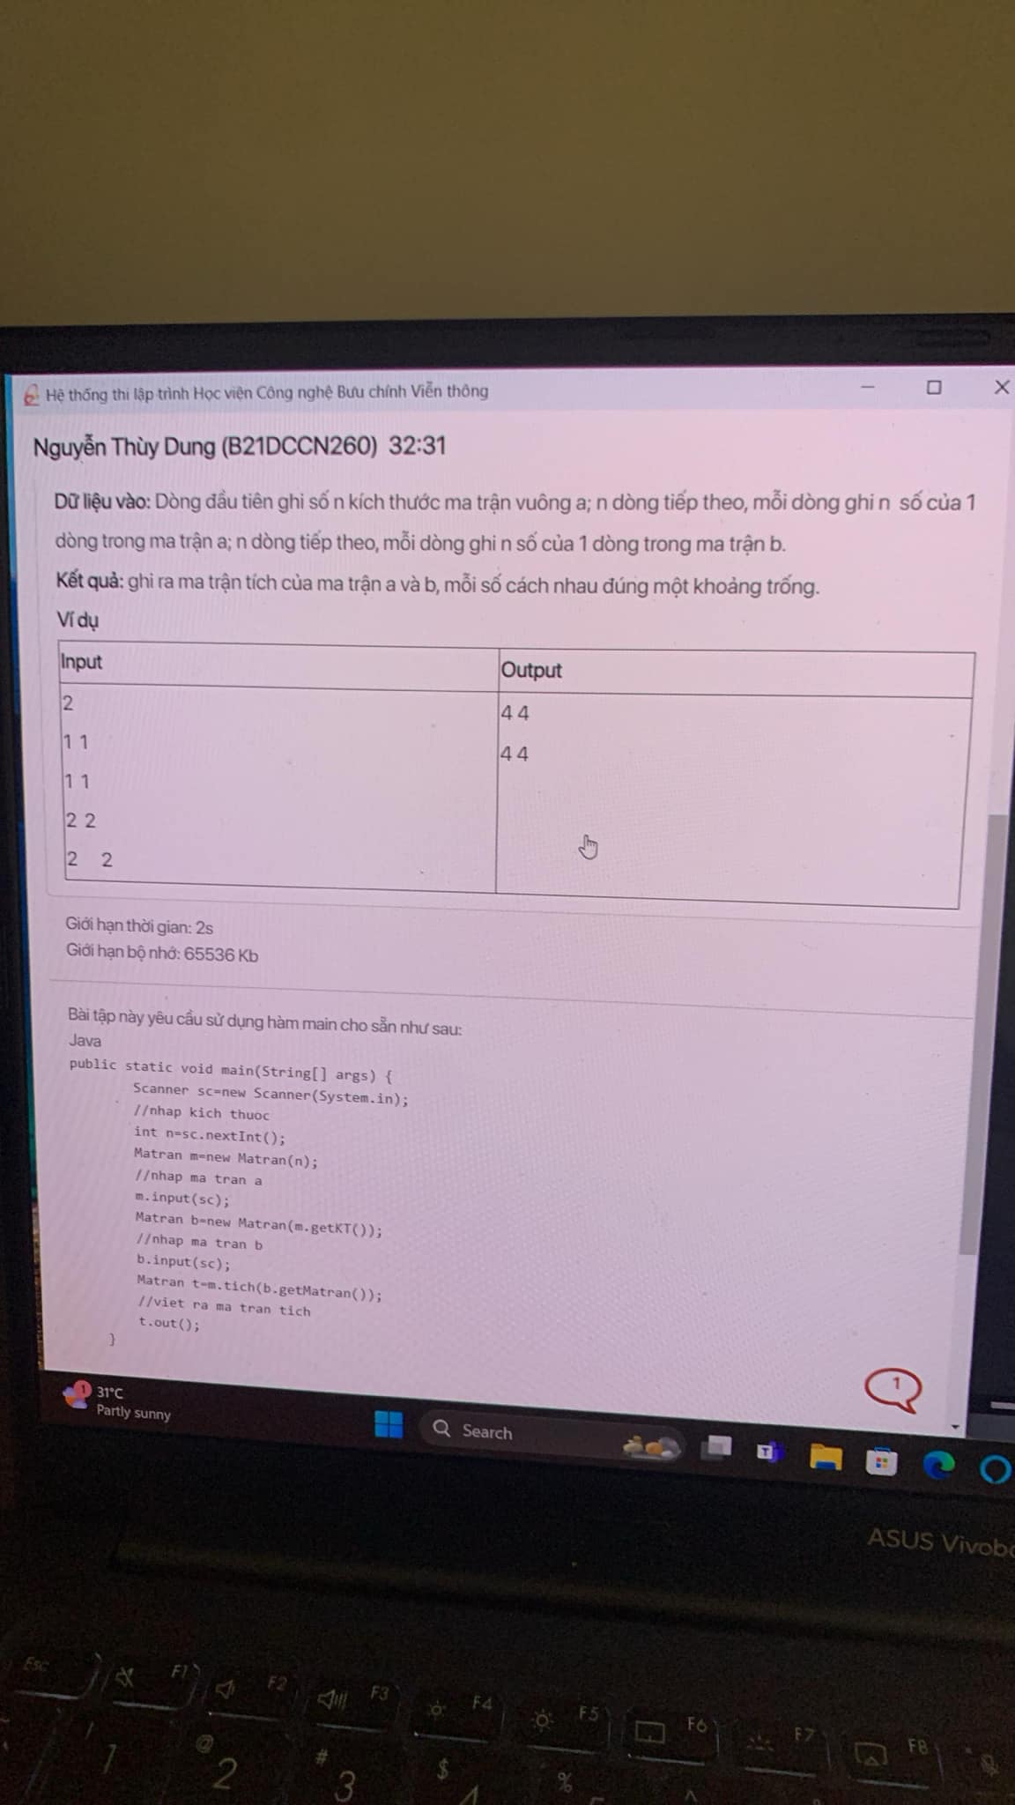

Bài giải tham khảo

**TÍCH HAI MA TRẬN:**

package BAI_TAP;

import java.util.*;

class Matran{

private int n;

private int [][]a;

public Matran(int n){

this.n = n;

this.a = new int[n][n];

}

public int [][] getMatran(){

return this.a;

}

public void input(Scanner sc){

for(int i = 0;i<this.n;i++){

for(int j = 0;j<this.n;j++){

this.a[i][j] = sc.nextInt();

}

}

}

public int getKT(){

return this.n;

}

public void out(){

for(int i = 0;i<this.n;i++){

for(int j = 0;j<this.n;j++){

System.out.print(this.a[i][j] + " ");

}

System.out.println();

}

}

public Matran tich(int[][] b) {

Matran res = new Matran(this.n);

for (int i = 0; i < this.n; i++) {

for (int j = 0; j < this.n; j++) {

res.a[i][j] = 0;

for (int k = 0; k < this.n; k++) {

res.a[i][j] += this.a[i][k] * b[k][j];

}

}

}

return res;

}

}

public class TICH_HAI_MA_TRAN {

public static void main(String[] args) {

Scanner sc = new Scanner(System.in);

//nhap kich thuoc

int n = sc.nextInt();

Matran m = new Matran(n);

//nhap ma tran a

m.input(sc);

Matran b = new Matran(m.getKT());

//nhap ma tran b

b.input(sc);

Matran t = m.tich(b.getMatran());

//viet ra ma tran tich

t.out();

}

}

**TẠO LỚP SẢN PHẨM**

package BAI_TAP;

import java.util.*;

class SanPham {

private static int counter = 0;

private String id;

private String ten, nhaSX;

private int soLuong;

private double gia, thanhTien;

public SanPham(String ten, String nhaSX, int soLuong, double gia) {

counter++;

this.id = String.format("%03d", counter);

this.ten = ten;

this.nhaSX = nhaSX.toUpperCase() + "-" + this.id;

this.soLuong = soLuong;

this.gia = gia;

this.thanhTien = soLuong * gia;

if (this.soLuong >= 20) this.thanhTien = this.thanhTien * 90 / 100;

}

@Override

public String toString() {

return this.nhaSX + " " + this.ten + " " + + this.soLuong + " " + String.format("%.1f %.1f", this.gia, this.thanhTien);

}

}

public class TAO_LOP_SAN_PHAM {

public static void main(String[] args) {

Scanner sc = new Scanner(System.in);

int n = Integer.parseInt(sc.nextLine());

String ten;

String nhaSX;

int soLuong;

double gia;

while (n-- > 0) {

ten = sc.nextLine();

nhaSX = sc.nextLine();

soLuong = Integer.parseInt(sc.nextLine());

gia = Double.parseDouble(sc.nextLine());

SanPham p = new SanPham(ten, nhaSX, soLuong, gia);

System.out.println(p);

}

}

}

/*

2

Galaxy A53

samsung

10

100

C21 Plus

Nokia

30

100

*/